Final Network Solution Summary
Organisation: A-Plus Institute
Solution: Network Option 2– Final Network Design
Prepared by: Leonardo Matias Ciarcia
Date: 01/09/2025
- Solution Overview

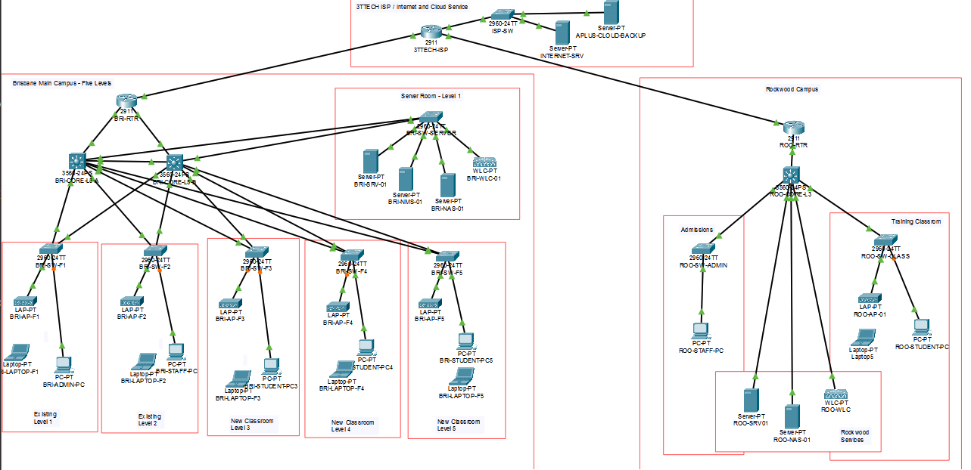
Network Option 2 is the final proposed network solution for A-Plus Institute. It has been designed to resolve the limitations of the current network and support the expansion of the Brisbane campus.
The design represents:
- Three existing Brisbane levels.
- Two new classroom levels.
- Five Brisbane levels in total.
- A separate Rookwood campus.
- A secure connection between Brisbane and Rookwood.
- Centralised network and business services.
- Managed wired and wireless access.
- Improved performance, security, reliability and scalability.
The computers and laptops shown in the topology are representative devices. They demonstrate how different users connect without requiring every employee and student device to be displayed.

2. Brisbane Campus Design
The Brisbane campus uses a hierarchical network design. Each of the five levels has a dedicated access switch:
- BRI-SW-F1
- BRI-SW-F2
- BRI-SW-F3
- BRI-SW-F4
- BRI-SW-F5
Levels 1 to 3 represent the existing Brisbane environment, while Levels 4 and 5 represent the two new classroom floors.
Each floor switch connects the local computers and wireless access point for that level. The floor switches connect back to two central Layer 3 core switches:
- BRI-CORE-L3-A
- BRI-CORE-L3-B
The two core switches provide central routing, improved capacity and redundancy. HSRP provides a resilient default gateway, while Spanning Tree Protocol prevents switching loops and maintains backup paths.
One redundant switch connection may appear amber in Packet Tracer. This is normal because Spanning Tree places the backup connection in a blocking state until it is required.

3. Wireless Network
Each Brisbane level has a managed wireless access point. The access points are centrally managed by BRI-WLC-01.
The wireless design provides:
- Centralised SSID configuration.
- Consistent wireless security.
- Corporate wireless access.
- Guest wireless access.
- Separation between corporate and guest users.
- Improved coverage across all five levels.
- Easier management of access points.
The final number and position of access points should be confirmed through a wireless site survey using NetSpot or TamoGraph.

4. Network and Services Area
The Brisbane Network and Services Area contains the central network resources. It is not represented as an additional floor.
The central services include:
- A network server for DHCP, DNS and other business services.
- A NAS device for local storage and backup.
- A network-monitoring server for SNMP, Syslog and performance monitoring.
- A Wireless LAN Controller for centralised wireless management.
- A server access switch.
- The Brisbane WAN router.
- The two Layer 3 core switches.
Centralising these services makes them easier to manage, secure, monitor and back up.

5. VLAN Segmentation
The final solution separates network traffic into VLANs based on business function.
The VLAN structure includes separate networks for:
- Staff.
- Students.
- Servers and network services.
- Network management and access points.
- Corporate wireless users.
- Guest wireless users.
VLAN segmentation reduces unnecessary broadcast traffic and prevents all devices from operating in one flat network. Inter-VLAN routing is performed by the Layer 3 core switches.
Access-control rules restrict communication between the VLANs. For example, guest users can access the Internet but cannot access internal staff, student, server or management networks.

6. Rookwood Campus
Rookwood remains a separate campus with its own:
- Router.
- Access switch.
- Wireless access point.
- Wireless LAN Controller where required.
- Staff and student devices.
- Local VLANs and IP addressing.
- Internet carrier connection.
A site-to-site IPsec VPN connects the Rookwood and Brisbane routers through the 3TTech carrier network. The VPN encrypts inter-campus traffic and allows authorised Rookwood users to access Brisbane services securely.

7. Internet and Carrier Connectivity
The Brisbane and Rookwood routers connect to the 3TTech carrier infrastructure. The routers provide:
- WAN connectivity.
- Network Address Translation.
- Internet routing.
- Site-to-site VPN services.
- Access-control security.
- Communication between the campuses.
The design recommends a 1 Gbps symmetrical Brisbane carrier service. Rookwood should have a minimum symmetrical service of 250 Mbps, with 500 Mbps preferred for additional growth capacity.

8. Security Features
The final design improves security through:
- VLAN separation.
- Access Control Lists.
- Guest wireless isolation.
- WPA2-secured wireless networks.
- Site-to-site IPsec encryption.
- Separate network-management addressing.
- Controlled access to servers and infrastructure.
- NAT at the Internet edge.
- Central monitoring and logging.
- Local and off-site backup arrangements.
Administrative access to routers, switches, controllers and servers should be protected using secure passwords and restricted to authorised personnel.

9. Capacity and Future Growth
Estimated busy-hour traffic is expected to increase from approximately 110 Mbps in the current network to:
- 250 Mbps in the first year after expansion.
- 360 Mbps by Year 3.
- 518 Mbps by Year 5.
With a 25% spare-capacity allowance, the expected Year 5 requirement is approximately 648 Mbps.
The final design supports this growth through:
- Gigabit access ports.
- Dedicated switches for each floor.
- Higher-capacity core connections.
- Dual Layer 3 core switches.
- Managed wireless access.
- Expandable VLANs and IP addressing.
- Improved carrier capacity.
- Centralised monitoring.

10. Final Outcome
Network Option 2 provides A-Plus Institute with a secure, scalable and manageable network. It supports five Brisbane levels, the separate Rookwood campus, wired and wireless users, central services and secure inter-campus communication.
The solution addresses the principal weaknesses of the current network by removing the dependence on one Brisbane access switch and one wireless access point. It also introduces segmentation, redundancy, centralised management, higher-capacity links and a secure VPN.
The design is suitable for implementation, subject to final confirmation of user numbers, carrier services, equipment availability and wireless site-survey results.

